Written Lab 6: Lab on Network IOS & Management

Key Networking Terms:

1. Command Line Interface- The command line prompt for inputting commands and going through the configuration modes. This is essential to know how to use since it will allow us to configure and access information on a router/network.
2. Telnet- This is a feature that has come up in multiple chapters; it allows us to login to devices on a network from another point on the network. This can be password protected. It is very useful so we do not have to access the actual CLI of a device to configure it as long as we can telnet into it.
3. Register Commands- A setting that tells the router where to look for bootup information. This is important when trying to use a specific configuration other than the typical one, like if passwords needed to be recovered.
   1. 0X2102= The default for Cisco routers and looks in NVRAM
   2. OX2101= The router will boot from ROM
   3. OX2142= Bypasses the startup-config in NVRAM and instead provides password recovery.

Procedures:

1. Lab Simulation #2
   1. Banners and Passwords
   2. Diagrams and Configuration
      1. 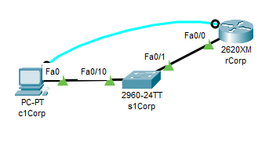Original network configuration

Default configuration with names and labels changed, no passwords or banners set

* 1. Lab Operation
     1. 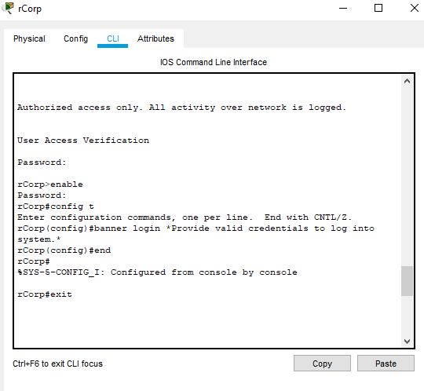Use global configuration mode to change banner messages
     2. 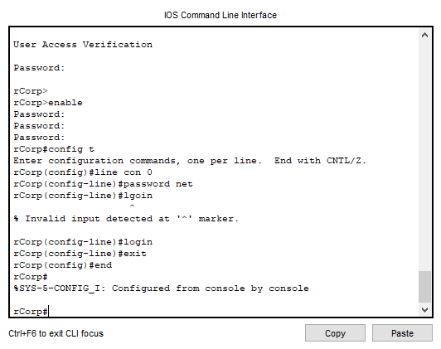And passwords…

1. Lab Simulation #3
   1. Banners and Passwords
   2. Diagrams and Configuration [diagram same as Lab#2]
      1. On the Router:
         1. running-config and startup-config identical
         2. Router name - rCorp
         3. IPs set on Fa0/0 interface 10.10.90.1/24 and it is up
         4. 16 vty (telnet/ssh) lines 0 - 15 available, login required but no password is set
         5. User exec mode password: net
         6. Privilege exec mode password: 343
         7. MOTD and Login banners set
      2. On the Switch:
         1. running-config and startup-config identical
         2. Switch name - s1Corp
         3. All 24 FastEthernet, and 2 Gig interfaces enabled
         4. Management native default vlan 1 (all ports belong to it) shutdown
         5. 16 vty (telnet/ssh) lines 0-15 available, login required but no password set
   3. Lab Operation
      1. 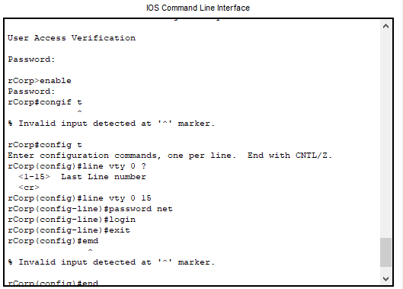Set passwords for all of the lines
      2. telnet from router to router

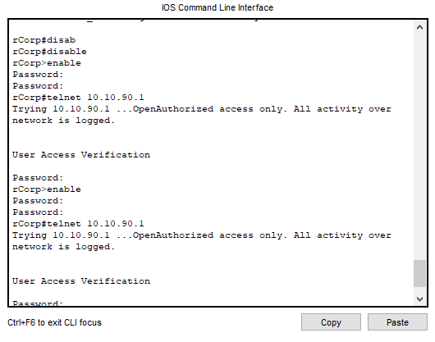

* + 1. telnet from pc to router

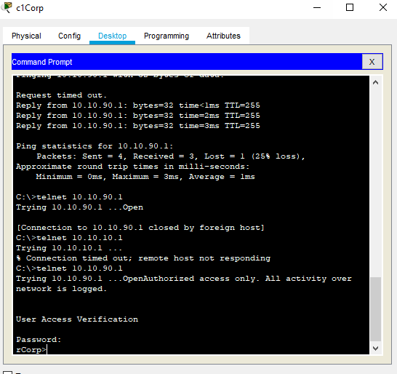

* + 1. tying hostnames to ip addresses

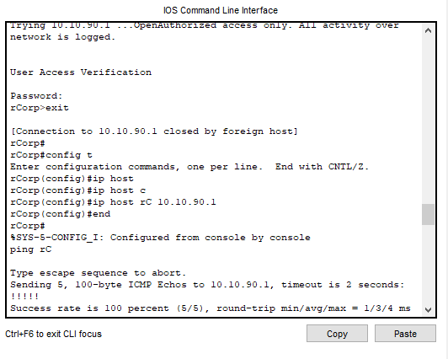

1. Lab Simulation #9
   1. Syslog and NTP
   2. Diagrams and Configuration
      1. Original network configuration

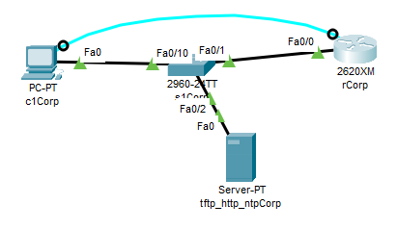

* + 1. On the Router:
       1. running-config and startup-config identical
       2. Router name - rCorp
       3. IPs set on Fa0/0 interface 10.10.90.1/24 and it is up
       4. 16 vty (telnet/ssh) lines 0 - 15 available, login required and passwor is: net
       5. User exec mode password: net
       6. Privilege exec mode password: 343
       7. MOTD and Login banners set
       8. ip hostname rC 10.10.90.1
    2. On the Switch:
       1. running-config and startup-config identical
       2. Switch name - s1Corp
       3. All 24 FastEthernet, and 2 Gig interfaces enabled
       4. Management native default vlan 1 (all ports belong to it) shutdown
       5. 16 vty (telnet/ssh) lines 0-15 available, login required but no password set
       6. Management vlan 1 10.10.90.3/24
       7. TFTP, HTTP, NTP servers 10.10.l90.2/24 added to switch at Fa0/2
  1. Lab Operations
     1. Set up logging for router

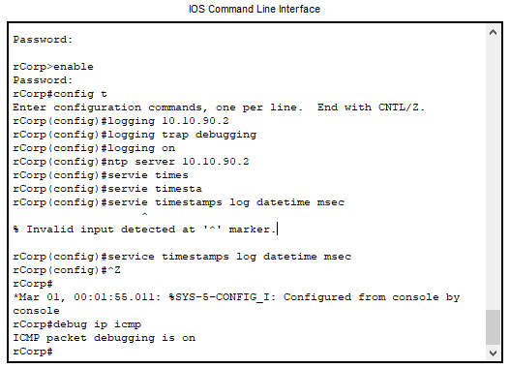

* + 1. Ping from the pc to see the syslog recording
    2. Then turn off the debugging to reduce the work for the server.

Conclusions and Discussion:

At the beginning I was wondering how we were going to incorporate the readings and the lab, but after reading and doing the labs, I realized that the reading is literally how to do the labs. It makes a lot of sense to focus on the labs for these chapters since they go through what the readings actually describe.

As I read and did the labs, a lot of elements came together for me. In many classes we have talked about the different features on routers, but to actually enable and see them is a different story. NTP and Syslog worked a little differently than I had envisioned; I had thought that they were something you’d have to configure an insane amount, but they honestly do not seem that bad and fairly automated. On the other hand, setting up unique the table for IPs and hostnames requires many more commands than I had previously thought, since I thought it would be automatically communicated at some point.

It is really hand that there is a software for handling the lab simulation, since that was something I was really worrying, since I’ve never had to revert all the changes I have made to computers in the lab, but I would have had to learn how if I used my own computer and network. Although, it seems like many of those worries would have been taken care of by backing up the original configuration for my router with the copy command. I look forward to experimenting and seeing how all the features interconnect and just what I can do inside a simulated network with no risk to my own technology.

Feedback:

